***Development of a Low-Cost, Open Software/Hardware Control, Command, and Communications Board for Cube Satellites (CubeSat)***

*Will Harrington, James Heath, Shan Quinney, and Michael Matthis*

***Abstract***

Attitude control systems are a huge enabling technology for amateur class high-powered rockets to be more useful as testbeds for high-altitude science, but they are presently too costly and technically complex to implement for most groups. A mechanical engineering senior capstone team at Portland State University is working to build a open-hardware extensible platform for attitude control of amateur and university class high-powered rockets.

***Introduction***

The Portland State Aerospace Society (PSAS) is an aerospace engineering student project at Portland State University dedicated to building low-cost, open-source/open-hardware high-powered suborbital sounding rockets, advanced avionics systems, and now venturing into cube satellite development. The group’s stated long term goal is to put a 1 kg nanosatellite into low Earth orbit. While an orbital rocket is in the development stages, PSAS is devoting much of its time in the creation of a working **CubeSat** with hopes of launching it via NASA’s ELANA program. A CubeSat is a miniature satellite that can be used for scientific research in space. It has a volume of one liter (10cm cube), and has a mass of no more than 1.33kg. An essential piece of the CubeSat is a module we refer to as C3, which stands for [Command, Control, and Communications](https://en.wikipedia.org/wiki/Command_and_control#Derivative_terms). They are defined as follows:

* **Command**
  + The exercise of authority based upon certain knowledge to attain an objective.
* **Control**
  + The process of verifying and correcting activity such that the objective or goal of command is accomplished.
* **Communications**
  + Ability to exercise the necessary liaison to exercise effective command between tactical or strategic units to command.

The C3 module will be responsible for some very important tasks such as facilitating communication between the ground station and CubeSat, and monitoring other electronics within the CubeSat payload. Developing such a module is not trivial and will require multiple phases of development.

A breakout board for the core component of this module, a microcontroller with an integrated transceiver, was produced in December of 2015 by a group of [ECE students from Portland State University](http://www.pdx.edu/ece/). The microcontroller is the MKW01Z128 from Freescale/NXP. We refer to it as the KW0x (colloquially: quakz). This chip was chosen by PSAS to be the heart of this module. It offers a wealth of features including, but not limited to, an integrated transceiver capable of sub-1GHz Radio-Frequency communication and [GFSK](https://en.wikipedia.org/wiki/Frequency-shift_keying#Gaussian_frequency-shift_keying).

The breakout board (pictured below) that was designed for this microcontroller was optimized for accessibility. It was designed by its creators to be "arduino-like". Indeed, there are rows of pin headers with labels and support circuitry to accommodate hardware developers. Some of the accommodations include literally access to EVERY pin, a USB2UART module for printing data to a serial port as human-readable [ASCII](https://en.wikipedia.org/wiki/ASCII) text, a 1 cell [LIPO](https://en.wikipedia.org/wiki/Lithium_polymer_battery) battery, a battery connector with battery charger chip, two tri-color LEDs with jumpers for access, [SWD](https://en.wikipedia.org/wiki/Joint_Test_Action_Group#Serial_Wire_Debug) connector, and the obligatory buttons and switches (on/off, reset).

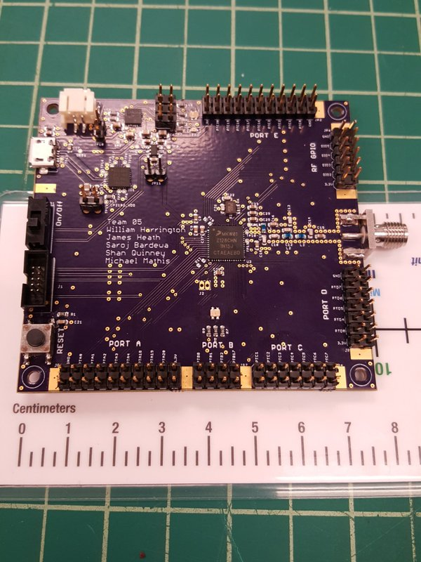

Significant software tools and firmware were also setup for the microcontroller. This includes an [OpenOCD](http://openocd.org/) config, [Makefile](https://en.wikipedia.org/wiki/Makefile), header file containing all the register addresses, some basic blink an LED caliber code, and a SPI driver.

Building on this foundation, a group of ECE students should be able to complete a Sputnik prototype that can be used for a balloon test by June 2016. The project should be scoped for no more than 16 weeks.

At the heart of Sputnik is the KW0x and the Radio Infrastructure. This is the communications pipeline. The KW0x will need support circuitry similar to that in the breakout board. It is connected to the System Controller and Payload via [UART](https://en.wikipedia.org/wiki/Universal_asynchronous_receiver/transmitter).

The Radio Infrastructure will consist of a [bandpass filter](https://en.wikipedia.org/wiki/Band-pass_filter), AC blocking network, a [Low-Noise Amplifier](https://en.wikipedia.org/wiki/Low-noise_amplifier), and a [Power Amplifier](https://en.wikipedia.org/wiki/RF_power_amplifier). It will be expecting a 50ohm [impedance](https://en.wikipedia.org/wiki/Electrical_impedance) for its load (the antenna) which is not within the scope of this project. It will need to be capable of producing 1 Watt of power (~30dBm) for long distance communication.

***Significance***

The most direct application of an attitude control system for high powered rocketry is counteracting the deleterious effects of weather cocking (that is, the tendency of rockets to steer into the wind). Aerodynamic fins are often used in conjunction with nose cone weights to move the rocket’s center of pressure well behind the center of mass such that corrective moments are produced for non­zero angles of attack. Weather cocking is a side ­effect of this need to use large fins for passive stabilization. Local wind speeds change the fluid velocity vector so that it is no longer strictly vertical for a rocket in flight. Ultimately this causes rockets to squander impulse in accelerating laterally. By using an attitude control system for active stabilization fin sizes can be reduced and the rocket’s maximum altitude

at apogee can be improved. An inexpensive open architecture attitude control system could potentially make amateur class rockets into more generally useful scientific platforms for research in the microgravity physics, meteorology and atmospheric science, and infrared and x­-ray astronomy fields. More ambitiously, full attitude control is required for pitch­over maneuvers needed for orbital trajectories, and is useful for range safety of extremely high altitude suborbital sounding rockets. Additionally, boundary layer control remains a largely unexplored technology in the amateur high powered rocketry field.

There is very little inherently new in designing cold gas attitude control systems; such systems already have a very high technology readiness level. Currently attitude control systems are not widely used by university rocketry groups largely for cost and technical complexity reasons. However, it remains a key enabling technology for low cost space access and therefore research regarding low­ cost attitude control systems is highly relevant to the overarching goals of NASA’s Space Technology Mission Directorate, particularly in the advancement of small spacecraft technology. Cold­-gas systems, while of low performance, are comparatively safe to operate such that they can be used by high turnover university student groups, and are less expensive and more technically feasible to

build than gimbaled thrust attitude control systems.

***Plan of Work***

The capstone team is currently at the stage of static testing on single stream vernier thrusters to validate numerical models of nozzle performance, tank thermodynamics, and flow componentry performance. Following this captive tests of a complete RCS module either suspended by cable or by 3-axis air bearing to test control law implementation schemes. Portland State University senior capstone presentations take place in early June 2015; at this point it is expected that static and captive testing of the RCS module will be complete. Finally the RCS module will be integrated on the PSAS LV3 stack for a demonstration flight in mid­ June 2015. We plan to mitigate testing risks by using the RCS in a roll control capacity only for its inaugural flight.